Catalase Enzyme Reaction Student Experiment - Eden Tomes

# Research Question:

How does increasing the volume of catalase solution (representing different enzyme concentrations) affect the rate of oxygen gas production when reacting with a constant volume and concentration of hydrogen peroxide?

# Rationale:

Cells, the fundamental units of life, depend on a multitude of biochemical reactions for survival and function, collectively known as metabolism (*Biology LibreTexts*, 2016). Many of these essential reactions would occur too slowly to sustain life without biological catalysts called enzymes (*Cooper*, 2000). Enzymes, primarily proteins, accelerate reaction rates by lowering the activation energy. They achieve this by binding to specific reactant molecules, or substrates, at a region called the active site, facilitating their conversion into products (*Robinson*, 2015).

Catalase is a crucial enzyme found in nearly all aerobic organisms, playing a vital protective role. It catalyses the decomposition of hydrogen peroxide (H₂O₂), a toxic byproduct of cellular metabolism, into harmless water (H₂O) and oxygen (O₂) (*Zamocky et al.*, 2008). This detoxification prevents oxidative damage to cellular components, a key aspect of how cells maintain homeostasis (*Nandi*, 2019).

The rate of enzyme-catalysed reactions is influenced by factors such as temperature, pH, substrate concentration, and enzyme concentration (*Robinson*, 2015). While a previous experiment explored temperature effects, this investigation focuses on how varying enzyme concentration impacts reaction rates. According to established enzyme kinetics, when substrate is abundant, the initial reaction rate is directly proportional to the enzyme concentration (*Aebi*, 1984). This is because more enzyme molecules mean more active sites are available to process the substrate, leading to faster product formation (*Robinson*, 2015).

This experiment aims to systematically investigate how altering the volume of catalase solution, thereby changing its effective concentration, affects the initial rate of oxygen production from hydrogen peroxide decomposition. By keeping substrate concentration, volume, and temperature constant, the study will isolate the influence of enzyme quantity on reaction rate. This will provide insight into how cells can regulate metabolic pathways by controlling enzyme availability.

# Methodology:

## Original Experiment

The original experiment investigated enzyme activity by reacting 1mL of stock catalase solution (yeast) with a set volume of hydrogen peroxide (10mL) in a reaction chamber. The chamber is submerged in a room-temperature water bath. Oxygen gas, the product of the reaction, is collected over water in an inverted measuring cylinder, and its volume is recorded at regular time intervals (every 30 seconds for 5 minutes) to determine the rate of reaction.

## Modifications

The original experimental design was modified to specifically address the research question concerning the effect of enzyme concentration on reaction rate. These modifications involved refinement for improved data quality and redirection to investigate the chosen variable.

The experimental procedure was refined to enhance the reliability of the collected data by conducting three independent trials for each of the tested volumes of catalase solution (1mL, 2mL, and 4mL). This replication improves the precision of the results by allowing for the calculation of mean oxygen production volumes and standard deviations. Averaging the outcomes from multiple trials helps to minimize the impact of random errors, such as slight variations in measurement or inconsistencies in bubble collection, thereby providing a more consistent and trustworthy dataset for each enzyme concentration.

The experiment was redirected from its original focus to directly investigate the new research. This was achieved through the systematic variation of the enzyme quantity. Instead of using a single volume, three different volumes of catalase solution were tested: 1mL (as a baseline, identical to the original method), 2mL, and 4mL. Since the stock catalase solution's concentration is constant, altering its volume directly changes the total amount of enzyme, and thus the effective enzyme concentration in the reaction mixture.

## Safety & Ethical Considerations

|  |  |  |
| --- | --- | --- |
| **Hazard** | **Identified Risk(s)** | **Control Measure(s)** |
| Hydrogen Peroxide (H202) | * Skin irritation or mild chemical burns. * Eye irritation or damage. | * Wear safety goggles and a lab coat at all times. * Handle H2O2 with care to avoid spills. * If H2O2 contacts skin, rinse immediately with plenty of water |
| Glassware (test tubes, beakers) | * Cuts from breakage. | * Handle carefully and avoid excessive force. * Keep glassware away from the edge of the bench. * Dispose of any broken glassware in a designated broken glass bin. |
| Chemical Spills | * Slip hazard on the floor. * Contamination of the work area or equipment. | * Clean up any spills immediately with paper towels as per teacher instructions. * Work on a clear, uncluttered bench space. |

# Processed Data + Calculations:

Example Calculations

|  |  |
| --- | --- |
| **Calculation** | **Example** |
| Mean oxygen volume |  |
| Standard deviation (SD) for a sample population | Standard deviation was calculated in excel by using the STDEV.S and the three trial measurements for each catalase volume. For 1mL: |
| Standard error | Standard error was calculated in excel by dividing the standard deviation by the square root of the sample size. For 1mL: |
| Upper/lower limit | The upper and lower limit for each catalase volume was calculated as follows: |

Figure 1 – Results Table: Volume of Oxygen Present After 300 Seconds  
(values are in mL and rounded to 2 decimal places)

|  |  |  |  |
| --- | --- | --- | --- |
|  | **1mL Catalase** | **2mL Catalase** | **4mL Catalase** |
| **Trial 1** | 4.00 | 0.70 | 11.00 |
| **Trial 2** | 3.00 | 5.00 | 8.50 |
| **Trial 3** | 0.70 | 5.00 | 4.50 |
| **Mean** | 2.57 | 3.57 | 8.00 |
| **Std. Deviation** | 1.69 | 2.48 | 3.28 |
| **Std. Error** | 0.98 | 1.43 | 1.89 |
| **Upper Limit** | 5.95 | 8.53 | 14.56 |
| **Lower Limit** | 0.00 | 0.00 | 1.44 |

Figure 2 – Column Graph:  
(standard deviations are represented by error bars)

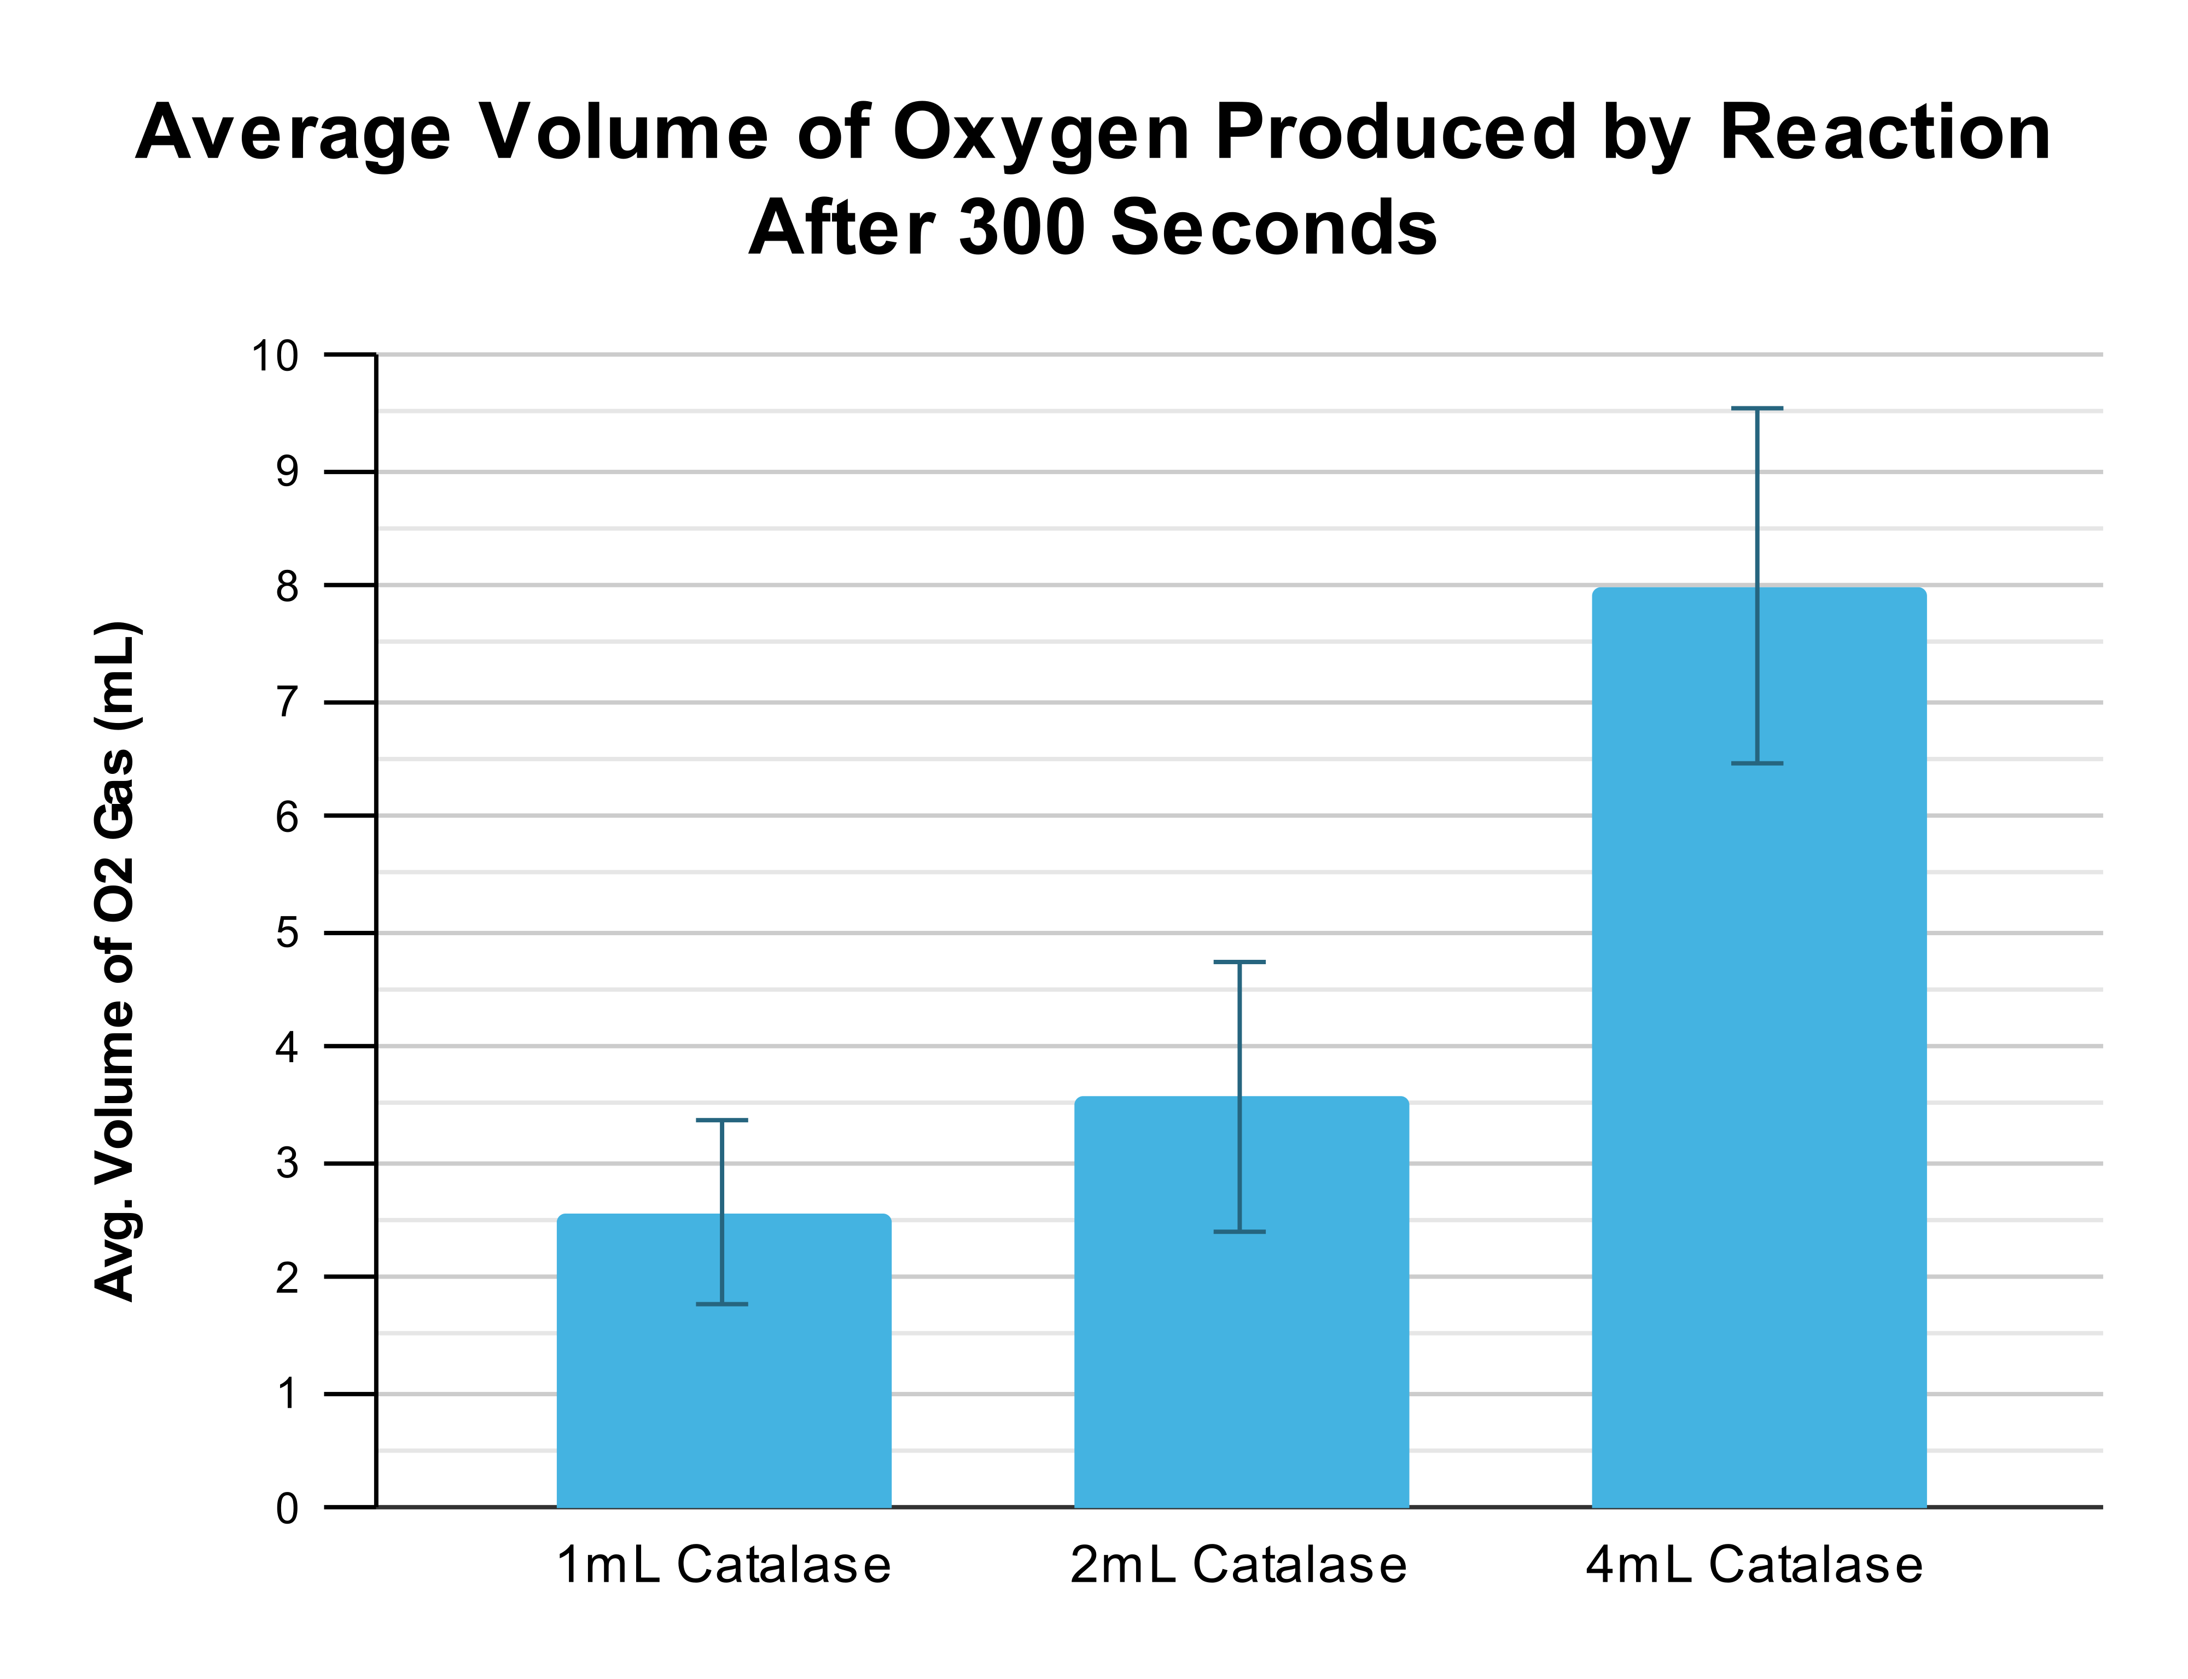

Figure 3 – Line Graph:  
(displays mean oxygen volume over a 300 second period)

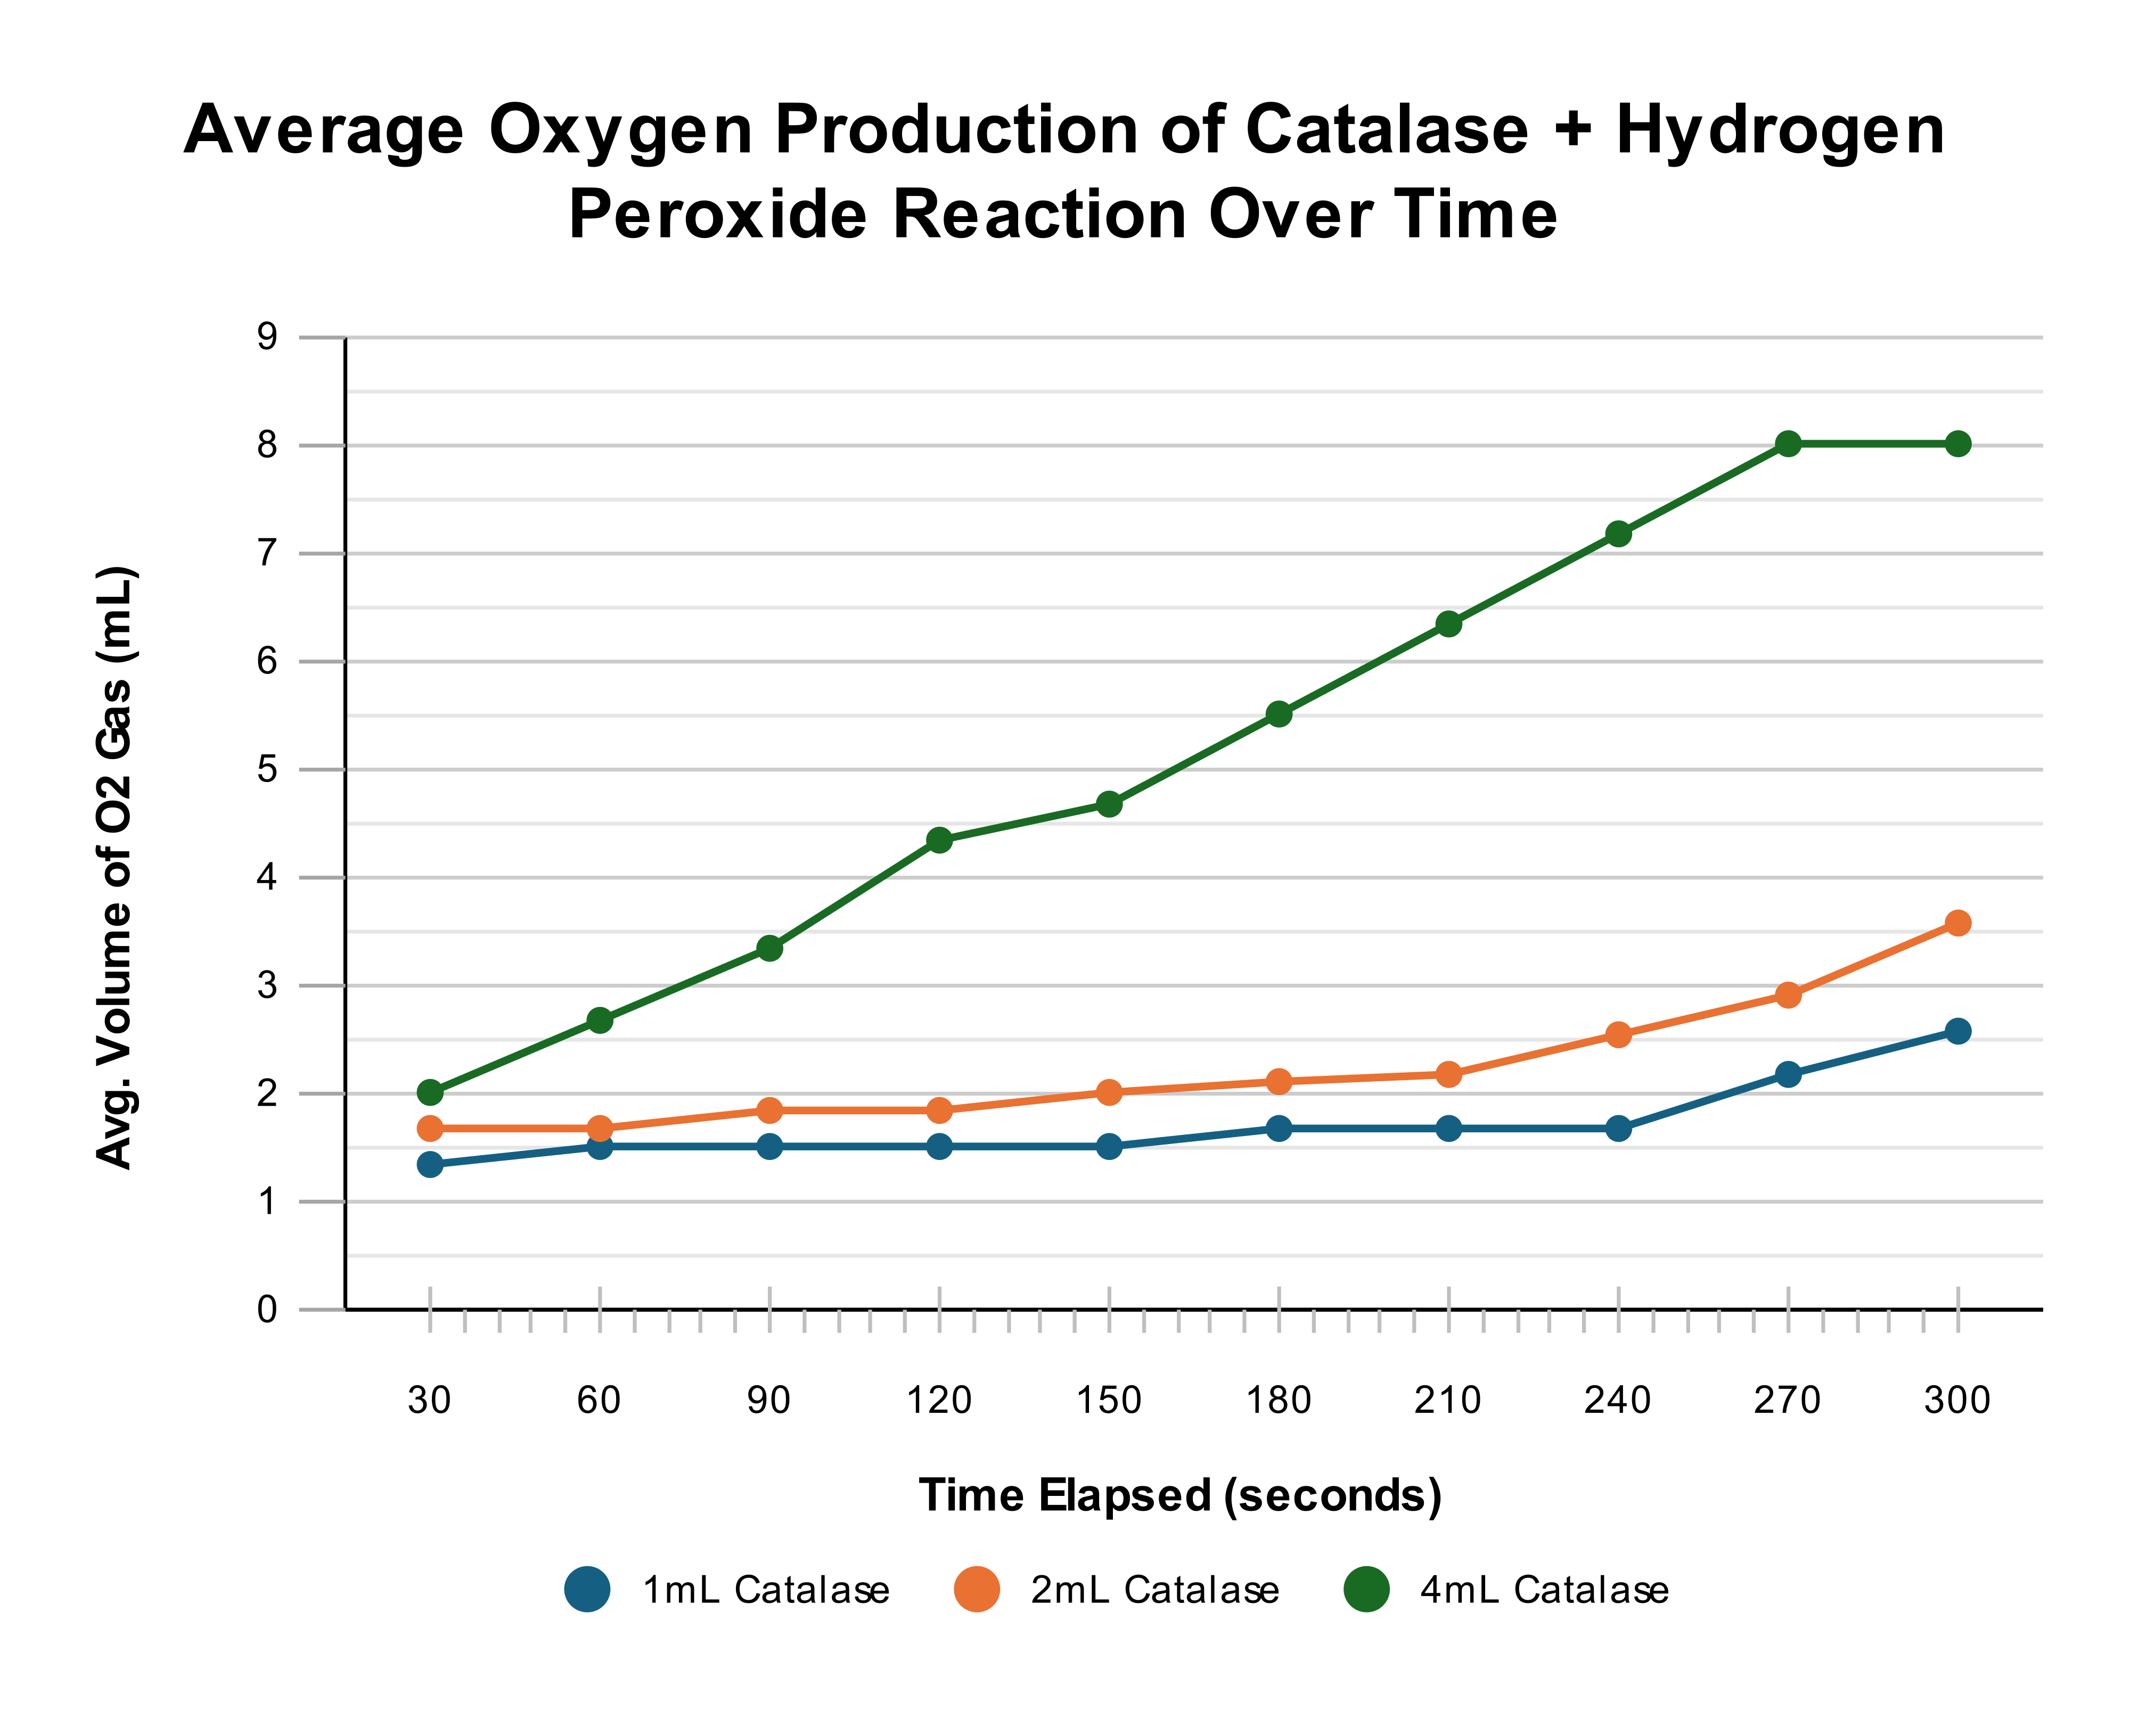

# Analysis of Evidence:

The experimental data collected indicates a relationship between the volume of catalase solution used and the amount of oxygen gas produced. As shown in Figure 1, the mean volume of oxygen produced after 300 seconds increased with higher volumes of catalase solution. Specifically, the 1mL catalase condition yielded a mean of 2.57 mL of O₂, the 2mL condition produced a mean of 3.57 mL, and the 4mL condition resulted in a mean of 8.00 mL of O₂. This general trend is visually represented in the column graph (Figure 2), where the height of the bars increases with catalase volume.

The line graph (Figure 3), plotting oxygen volume over time for each catalase concentration, would be expected to illustrate the rate of reaction. A steeper initial slope on this graph would correspond to a faster rate of oxygen production. Based on the final mean volumes, it is evident that the 4mL catalase condition exhibited the fastest initial reaction rate, followed by the 2mL condition, and then the 1mL condition, though the graph itself would provide more direct evidence of these rates over the 5-minute period.

However, there was considerable variability within the trials for each enzyme volume, as highlighted by the standard deviations presented in Figure 1: 1.38 mL for the 1mL catalase trials, 2.03 mL for the 2mL trials, and 2.68 mL for the 4mL trials. For example, Trial 3 for 1mL catalase (0.70 mL) was substantially lower than Trial 1 (4.00 mL). Similarly, for the 2mL catalase, Trial 1 (0.70 mL) was markedly different from Trials 2 and 3 (both 5.00 mL). The 4mL catalase condition also demonstrated a spread, with Trial 3 (4.50 mL) being less than half of Trial 1 (11.00 mL). This degree of variation suggests potential inconsistencies or the influence of random errors during the experimental procedure.

# Evaluation:

## Limitations Of Evidence

The experimental data exhibits considerable variability between trials for each enzyme concentration (as highlighted by the large standard deviations in Figure 1: 1mL - 1.38 mL, 2mL - 2.03 mL, 4mL - 2.68 mL). For example, Trial 3 for 1mL catalase (0.70 mL) was significantly lower than Trial 1 (4.00 mL), and Trial 3 for 4mL catalase (4.50 mL) was less than half of Trial 1 (11.00 mL). This wide spread of results suggests low reliability in terms of precision and limits the confidence in drawing firm conclusions about the exact linearity of the response, especially given the implied wide confidence intervals for the mean values (Figure 2). The presence of unconfirmed extreme values (like the low 1mL Trial 3) may also have altered the calculated means.

## Sources Of Error Affecting Reliability

* Inconsistent reaction initiation and submersion: Variations in the time taken to seal the chamber and submerge it likely led to variable amounts of initial gas escaping or delays in temperature equilibration, randomly affecting the volume of oxygen collected.
* Variable bubble collection efficiency: Inconsistencies in the delivery tube positioning or bubbles adhering to surfaces could lead to random underestimations of gas volume, as suggested by the wide range within trials.
* Subjectivity in reading gas volume: Parallax errors or disturbances from continuous bubbling could introduce random inaccuracies in volume measurements.
* Lack of homogeneity in catalase solution: If the stock yeast solution was not thoroughly mixed, the actual amount of enzyme in each measured aliquot could have varied, introducing random fluctuations in effective enzyme concentration.

## Sources Of Error Affecting Validity

* Substrate depletion at higher enzyme concentrations: For the 4mL catalase condition, the 10mL of hydrogen peroxide likely became a limiting reactant before the 5-minute observation period concluded. This means the total oxygen collected at 300 seconds does not accurately reflect a rate solely dependent on enzyme concentration throughout the entire period, underrepresenting the true initial rate.
* Confounding variable of total reaction volume: The methodology varied the total reaction volume (11mL, 12mL, 14mL). This caused the initial substrate (H₂O₂) concentration to differ across conditions, being most diluted with 4mL catalase. This compromises the isolation of enzyme concentration as the sole independent variable.
* Dissolution of oxygen in water: Some produced oxygen would have dissolved into the collection water, leading to a systematic underestimation of the actual gas volume, affecting the accuracy of the results.
* Degradation of hydrogen peroxide stock: If the H₂O₂ solution was not fresh or its concentration was lower than stated, the overall reaction rates and oxygen yields would be systematically lower than theoretically possible, affecting the accuracy of the measured product.

## *Suggested Improvements & Extensions*

Improvements to Current Methodology:

* To minimize variations in initial reaction conditions and gas loss, standardize reaction initiation and temperature equilibration. This could involve pre-equilibrating solutions to the water bath temperature and using a more controlled injection method for enzyme addition, improving precision and reliability.
* To ensure the initial substrate (H₂O₂) concentration is identical across all conditions, control the total reaction volume. Adding a buffer or distilled water to make up the volume difference for varying catalase amounts would improve experimental validity.
* To enhance the accuracy and precision of gas measurements, improve gas collection and measurement techniques. Using a gas syringe instead of water displacement would eliminate oxygen dissolution and provide more direct volume readings.
* To increase the statistical power and reduce the impact of individual anomalies, increase the number of trials and replicates (e.g., 5 or more) for each enzyme concentration. This would provide a more reliable mean.
* To more accurately address the effect of enzyme concentration on reaction rate (as per enzyme kinetics), focus on initial reaction rates. Data should be collected at shorter intervals (e.g., every 10-15 seconds) during the initial phase, allowing for the calculation of the linear slope. This would improve the validity of the rate determination.
* To ensure consistent enzyme concentration across trials, ensure homogeneity of the enzyme solution by thoroughly mixing the stock yeast solution before each aliquot is taken.

Possible Extensions:

* Investigate a Wider Range of Enzyme Concentrations: Extending the experiment to include more, and possibly smaller or larger, increments of enzyme concentrations could help to more clearly define the relationship between enzyme concentration and reaction rate, and to identify if/when the enzyme concentration itself becomes saturating or if substrate limitation occurs at higher concentrations.
* Determine the Effect of Substrate Concentration: A redirected experiment could investigate how varying the concentration of hydrogen peroxide affects the reaction rate while keeping the enzyme concentration constant. This would allow for a fuller exploration of enzyme kinetics.
* Study the Effect of pH or Inhibitors: Once the base experiment is reliable, it could be extended to investigate how other factors like pH or the presence of specific enzyme inhibitors affect catalase activity.

# Conclusion:

In conclusion, the experimental evidence indicates that increasing the volume of catalase solution, and therefore the enzyme concentration, resulted in an increased mean volume of oxygen gas produced from the decomposition of hydrogen peroxide within the 300-second observation period. This generally supports the hypothesis that a higher enzyme concentration leads to a faster reaction rate, assuming substrate is not limiting.

However, significant limitations were identified in the experimental design and execution. The considerable variability within trials for each enzyme concentration, as evidenced by large standard deviations, and potential confounding factors such as substrate depletion at higher enzyme concentrations and the alteration of total reaction volume, impact the reliability and validity of the quantitative data. While a positive trend between enzyme volume and oxygen production was observed, these limitations mean that a definitive, precise quantitative relationship cannot be confidently established from this data alone. Further investigation with a refined methodology, including more trials, consistent total reaction volumes, and analysis of initial reaction rates, would be required to provide more robust support for the expected direct proportionality.

# Reference List:

1. Aebi, H. (1984). Catalase in vitro. *Methods in Enzymology*, [online] 105, pp.121–126. doi:[https://doi.org/10.1016/s0076-6879(84)05016-3.](https://doi.org/10.1016/s0076-6879(84)05016-3)
2. Biology LibreTexts. (2016). *1.16: Types of Biochemical Reactions*. [online] Available at: [https://bio.libretexts.org/Bookshelves/Introductory_and_General_Biology/Introductory_Biology_(CK-12)/01%3A_Introduction_to_Biology/1.16%3A_Types_of_Biochemical_Reactions.](https://bio.libretexts.org/Bookshelves/Introductory_and_General_Biology/Introductory_Biology_(CK-12)/01%3A_Introduction_to_Biology/1.16%3A_Types_of_Biochemical_Reactions)
3. Cooper, G. (2000). *The Central Role of Enzymes as Biological Catalysts*. [online] National Library of Medicine. Available at: <https://www.ncbi.nlm.nih.gov/books/NBK9921/>.
4. Nandi, A. (2019). Role of Catalase in Oxidative Stress- and Age-Associated Degenerative Diseases. *Oxidative Medicine and Cellular Longevity*, [online] 2019(9613090). doi:<https://doi.org/10.1155/2019/9613090>.
5. Robinson, P. (2015). Enzymes: Principles and Biotechnological Applications. *Essays in Biochemistry*, [online] 59(1), pp.1–41. doi:[https://doi.org/10.1042/bse0590001.](https://doi.org/10.1042/bse0590001)
6. Zamocky, M., Furtmüller, P.G. and Obinger, C. (2008). Evolution of Catalases from Bacteria to Humans. *Antioxidants & Redox Signaling*, [online] 10(9), pp.1527–1548. doi:[https://doi.org/10.1089/ars.2008.2046.](https://doi.org/10.1089/ars.2008.2046)

# Appendix:

## Raw Data

## A